Title: Times New Roman; Size-18; 1.15 Line Spacing; Paragraph Spacing: 0 line; Centre with Title Tag

Because of the double-blind review, the authors’ information should not be included in this file. Please put authors’ information in the separated Title Page.

Page setup: Page size: A4; Margin: Top = 2.5 cm; Bottom = 2 cm; Left = 1.27 cm; Right = 1.27 cm; Pages should be numbered

Copyright © 2023 by Authors, Published by International Journal for Innovation Education and Research. Original Content from this work may be used under the terms of the Creative Commons Attribution 4.0 licence. Any further distribution of this work must maintain attribution to the author(s) and the title of the work, journal citation and DOI.
DOI : https://doi.org/10.31686/ijier.vol11.issX.0000
Received: 2023-00-00 Accepted: 2023-00-00 Published: 2023-00-00
How to Cite: Authors (2023). Paper title. International Journal for Innovation Education and Research, 11(11), 35-47. https://doi.org/10.31686/ijier.vol11.issX.0000

Body Text:
Front: Times New Roman; Size: 12; 1.15 Line Spacing; Paragraph Spacing: 0 line;

Please use MS Tag Style for best result for your paper indexing

Abstract Heading Level-1
text text text text text text text text text text text text text text text text text text text text text text text text text text text text text text text text text text text text text text text text text text text text text text text text text text

Keywords: text; text; text; text; text; text;

1. Heading Level-1
text text text text text text text text text text text text text text text text text text text text text text text text text text text text text text text text text text text text text text text text text text text text text text text text text text

1.1 Heading Level-2
text text text text text text text text text text text text text text text text text text text text text text text text text text text text text text text text text text text text text text text text text text text text text text text text text text

Table 1. The capitals, assets and revenue in listed banks
 | text text text | text text text | text text
text text text text text
text text

Description for the above table.
text text text text text text text text text text text text text text text text text text text text text text text text text text text text text text text text text text text text text text text text text text text text text text text text

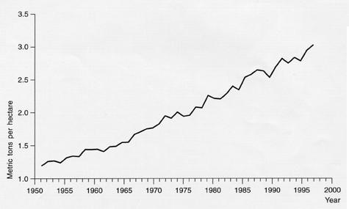
Figure 1. text text text text text.

Description for above figure. Please insert the figure into text. The figure should be high quality. Normally, 300 dpi is required.

1.1.1 Heading Level-3
text text text text text text text text text text text text text text text text text text text text text text text text text text text text text text text text text text text text text text text text text text text text text text text text text text

2. Heading Level-1
text text text text text text text text text text text text text text text text text text text text text text text text text text text text text text text text text text text text text text text text text text text text text text text text text text

2.1 Heading Level-2
text text text text text text text text text text text text text text text text text text text text text text text text text text text text text text text text text text text text text text text text text text text text text text text text text text

5. Conclusion, Heading Level-1
text text text text text text text text text text text text text text text text text text text text text text text text text text text text text text text text text text text text text text text text text text text text text text text text text text

6. Acknowledgement Heading Level-1
The research is financed by text text text text text text text text text text text text text text text text text text

7. References
- Bao, R., & Chen, J. (2022). Characteristics and problems of unplugged computer science curriculum for young children: Comparative and practical research based on the curriculum in four countries. International Journal for Innovation Education and Research, 10(4), 1–22. https://doi.org/10.31686/ijier.vol10.iss4.3700

- Cristo, H. S. de, Filho, A. S. N., Marinho de Aragão, J. W., & Saba, H. (2022). Media Bios and Artificial Intelligence: The dark side of Fake News. International Journal for Innovation Education and Research, 10(4), 23–33. https://doi.org/10.31686/ijier.vol10.iss4.3701

Appendix
Appendix 1. text text text text text

Appendix 2. text text text text text

Few guidelines to prepare your paper
- Creating an MLA and APA paper with citations and a bibliography (link)
- Using Quick Styles (link)
- Quick citations: zbib.org

